TOYOTA ESP9100 NET Machine Operating System Update

A. To verify the current Machine Operating System:
Place machine in test mode:
• On right side of control panel place DSW1-1 in on position
• Turn machine ON in 'Test Mode.'
• Press SET
• Make note of your current machine specs
- To download the newest Operating System version 2.0 :
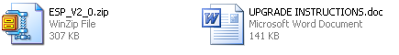
Note: These design downloads are in a zipped format. If you do not have a copy of WinZip to unzip this file, you may visit www.WinZip.com to download an evaluation version.
To download file:
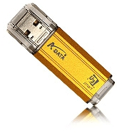
• Make a folder on your computer's hard drive (such as C:\opersys)
• Save the file to the new folder
• Double-click to unzip the file
• Place a thumb (or flash) drive in your computer's USB port
• Once unzipped save the three files to your USB port
• Once completed, remove the thumb drive and follow steps below
C. To update the Operating System:
Step 1: Detach the switch cover by loosening the screw.
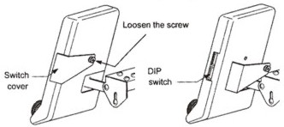

Updating Previous Version to 1.3
Step 2: Place switches:
• DSW1-1 on.
• DSW2-1 on.
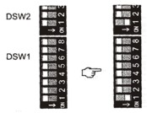 | 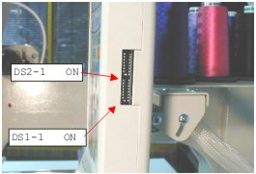

Step 3: Set the program disk.
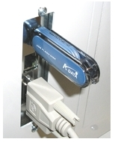
• Place the thumb drive in the embroidery machine's USB port.

Step 4: Turn ON the power switch at the power supply box.
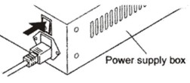

Step 5: Select the program to be installed.
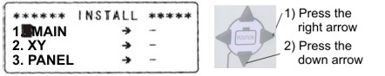
• Press the Right Arrow, followed by the Down Arrow. Repeat pressing the Right Arrow, followed by the Down Arrow 2 additional times (3 times total). The word "INSTALL" should appear next to "MAIN", "XY", and "PANEL".

Step 6: Verify current specs.
After update to version 2.0 is complete, your current specs
should be:
Panel | 2.0
Main | 2.0
XY | 2.0

Step 7: Complete installation.
• Press Set
• After install is complete (confirm "Install Complete" on display), power off machine, return all DIP switches to off and remove the thumb drive.

